**Proposed:** CLSTDN, SS-LSTM, ResNet-50

**Classification:** Normal, DDoS Attack, Botnet Attack

**Existing:** BSCNN, BRBNN, SMCNN

**Performance Metrics**

1. Accuracy-high
2. Precision-high
3. Recall-high
4. Computational time-low
5. Specificity-high
6. F1-score-high

**intha graph model aa potu thanga include 1 to 6**

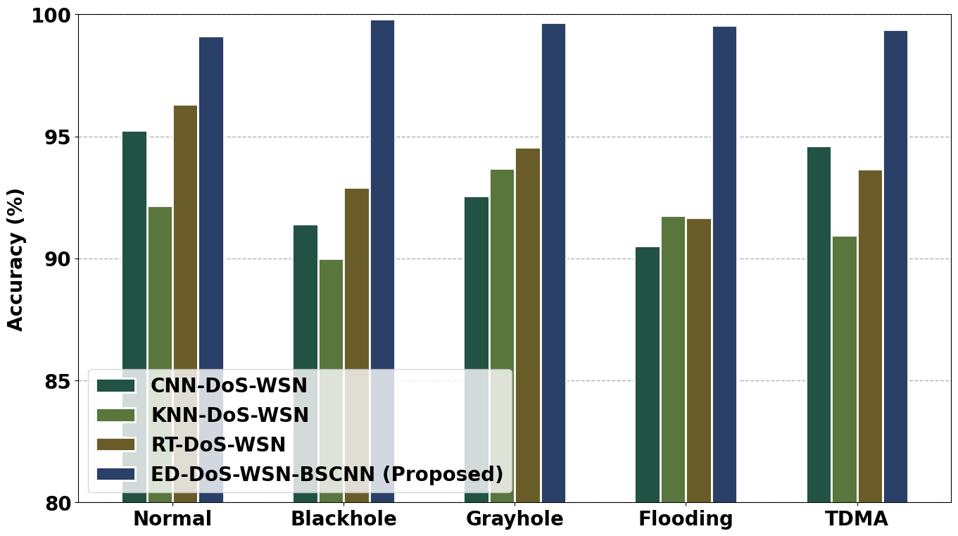

1. **ANOVA accuracy comparison graph**

Entha graph mathri potu thanga…

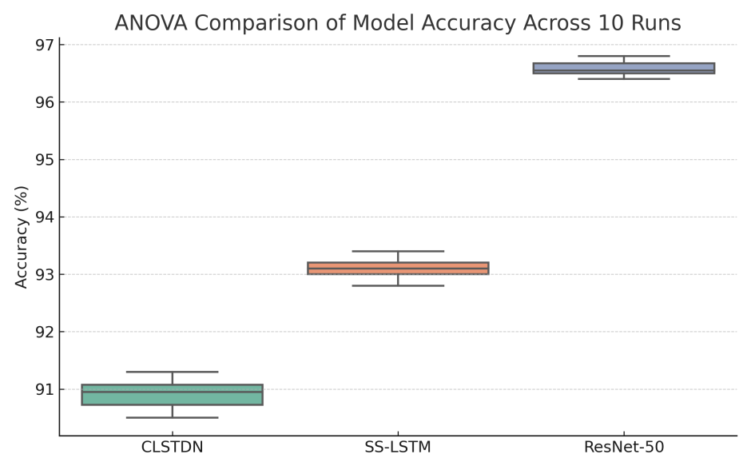

**8. T-Test comparison graph**

Entha graph mathri potu thanga…

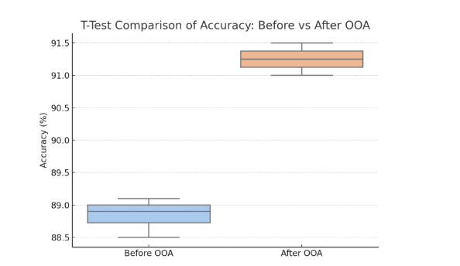

**9. Chi-Square Test**

Entha graph mathri potu thanga…

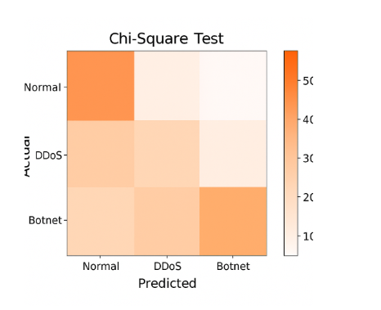

**10. Fitness curve for proposed OOA algorithm**

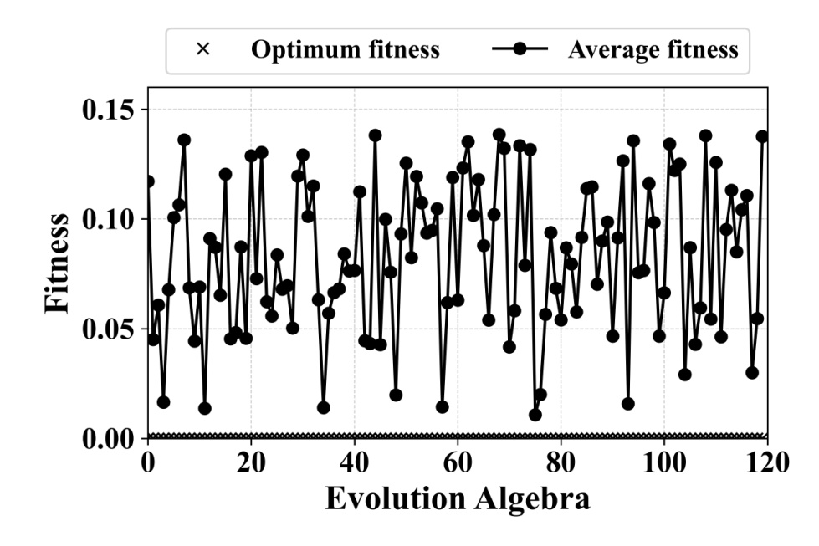

**11: convergence curve**

Proposed**: OOA**

Existing**: ATO, PSO, KOA**

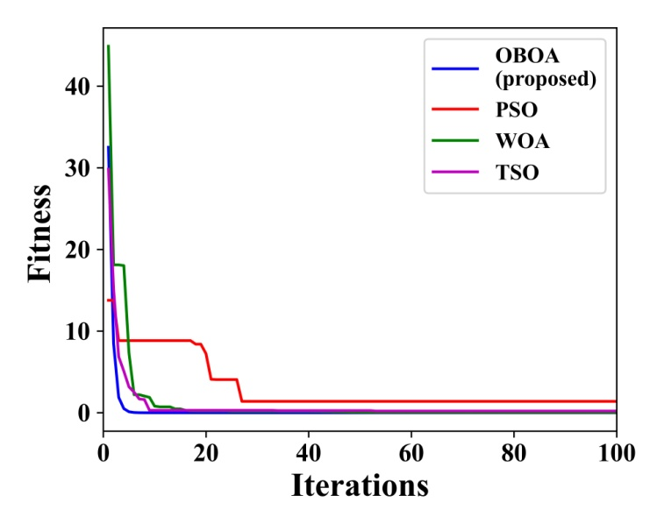

Give parameter table …..

Table 1: **CLSTDN**

|  |  |
| --- | --- |
| **Hyper parameters** | **Value** |
| Conv Layer |  |
| Batch Normalization |  |
| MaxPooling |  |
| LSTM Layer |  |
| Dropout Rate |  |

Table 2: **SS-LSTM**

|  |  |
| --- | --- |
| **Hyper parameters** | **Value** |
| LSTM Layer 1 |  |
| LSTM Layer 2 |  |
| LSTM Layer 3 |  |
| Dropout |  |
| Dense |  |

Table 3: **ResNet-50**

|  |  |
| --- | --- |
| **Hyper parameters** | **Value** |
| Flatten |  |
| Dense Layer |  |
| Dropout |  |

**Table 4: Ablation study outcomes**

|  |  |  |  |  |  |
| --- | --- | --- | --- | --- | --- |
| **Model variant** | **Accuracy (%)** | **Precision (%)** | **Recall (%)** | **F1-score (%)** | **Computational time (sec)** |
| With ATSUKF |  |  |  |  |  |
| Without ATSUKF |  |  |  |  |  |
| With OOA |  |  |  |  |  |
| Without OOA |  |  |  |  |  |
| CLSTDN + SS-LSTM + ResNet-50 (proposed) |  |  |  |  |  |